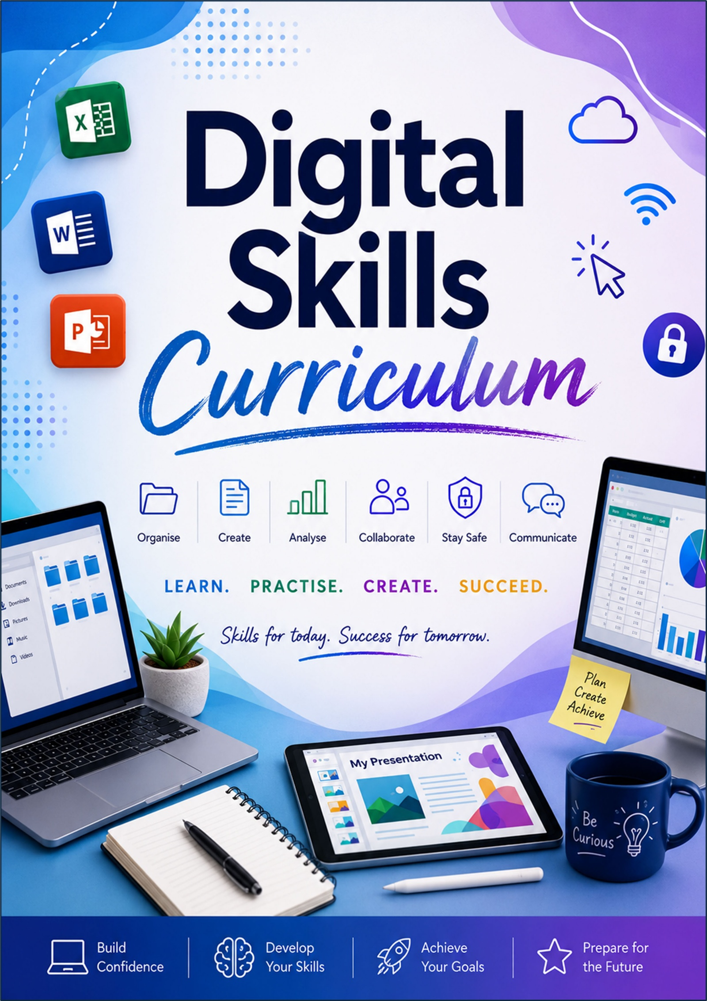
Rationale
The terms "digital native" and "digital immigrant" were established by education consultant Marc Prensky. He introduced this conceptual framework in his 2001 article, "Digital Natives, Digital Immigrants", published in the journal On the Horizon. Prensky created this binary metaphor to explain the growing generational gap in contemporary education and technology adoption.
Since these terms were established the digital world has completely metamorphasised. Computing curriculums in the UK moved away from ICT to Computer Science focus upskilling students in the world of coding. Teachers retrained in order to deliver the complex nuances of the new curriculum enabling a generation of students to upskill in a much more specialised subject. Many schools chose to remove basic ICT skills from their curriculum altogether in favour of them being taught by other subjects discretely within their limited curriculum time. Add this to a generation of students begin raised with smart technology within their homes and not necessarily PCs we have seen a dramatic change in competence.
Technology is consistently evolving. Handheld devices are becoming increasingly affordable and available. Children are primarily accessing home learning online through school-provided platforms. Most students (97%) have home internet access and utilize devices like laptops and tablets (54–72%). However, over half (51%) of students share devices relying then on their mobile device and 14% of less affluent households relying solely on smartphones (Ofcom). The way that students are accessing this learning is predominantly mobile based meaning that basic desktop skills are frequently misunderstood or missed completely, nor are they guaranteed this within schools as may provide tablet devices due to space and funding, thus creating another generational gap, a “digital super native” shall we say; a person well versed in handheld/mobile technology.
This “digital super native” has an inherent deficit of skills that are commonly associated with our more commonly known “digital native”, those who were brought up surrounded with desktop computing devices. The digital native was explicitly taught IT skills within the school curriculum as opposed the super native who has seen the reduction in ICT being taught within schools in favour of programming. This has lead to a paradigmatic shift in our student’s capabilities and the erosion of IT literacy. Nowadays, we commonly see in the classroom students who demonstrate:
- A Steady decline in IT literacy – the gap widens year on year.
- Lacking in technological fine motor skills such as mouse and keyboard practices
- Lacking in File Management skills - File, Directories, and Paths; the management of their system area is non-existent
- Shorter attention span – Mobile technology focuses on quick, sharp, snippets and therefore less ability to manage and remember multiple step procedures (interesting side fact – This has impacted many industries, even changing the music we are listening to with artists opting to ensure all songs have a useable 20-30 snippet that will be “tik-tokable” and captures the attention of young people).
- Need for immediacy – less resilience for complex tasks
- Less competent digital citizens ready for the UK workforce
The proposal is to build in a curriculum which builds these skills within the first half term/term of the student’s time in an ESW Secondary School.

12-Week Digital Skills Curriculum for School Students
This curriculum is designed to build confidence progressively, starting with the basics of using a computer and moving toward productivity, collaboration, online safety, and independent digital problem-solving.
The structure assumes:
- 1 lesson per week
- 60 minute sessions
- Mixed ability learners
- Practical, hands-on activities each week

Curriculum Overview
Week | Topic | Core Skill Focus
1 | Introduction to Digital Skills | Computer confidence & navigation
2 | File Management Essentials | Organising digital work
3 | Internet & Online Research | Safe and effective searching
4 | Word Processing Basics | Creating professional documents
5 | Intermediate Word Processing | Formatting & productivity tools
6 | Presentation Skills | Slides & communication
7 | Spreadsheets Basics | Data handling & formulas
8 | Email & Digital Communication | Professional communication
9 | Cloud Storage & Collaboration | Sharing and teamwork
10 | Cyber Safety & Digital Citizenship | Staying safe online
11 | Problem Solving & Troubleshooting | Independent tech confidence
12 | Final Digital Skills Project | Applying all learned skills

Week-by-Week Lesson Outline

Week 1 — Introduction to Digital Skills
Objectives
Students will:
- Understand basic computer terminology
- Navigate a desktop/laptop confidently
- Use keyboard and mouse effectively
- Log in and access applications
Topics Covered
- What is hardware vs software
- Operating systems overview
- Keyboard shortcuts
- Using a mouse/touchpad
- Opening, closing, minimising windows
- Logging in securely
Practical Activities
- Desktop scavenger hunt
- Keyboard shortcut challenge
- Personalising desktop background
Key Skills
- Confidence using devices
- Basic navigation
- Digital vocabulary

Week 2 — File Management Essentials
Objectives
Students will:
- Organise files logically
- Create folders and subfolders
- Save and retrieve work confidently
Topics Covered
- File explorer/finder
- Creating folders
- Naming files correctly
- File extensions
- Saving vs Save As
- USB drives/cloud basics
Practical Activities
- Create a school folder structure
- Organise messy files challenge
- Rename files using conventions
Key Skills
- Organisation
- Digital housekeeping
- Preventing lost work

Week 3 — Internet & Online Research
Objectives
Students will:
- Search effectively online
- Evaluate reliable sources
- Understand browser basics
Topics Covered
- Web browsers
- Search engine techniques
- Tabs and bookmarks
- Identifying trustworthy websites
- Avoiding misinformation
- Copyright and plagiarism basics
Practical Activities
- Research challenge
- Compare reliable vs unreliable websites
- Create bookmarks folder
Key Skills
- Research literacy
- Critical thinking
- Efficient browsing

Week 4 — Word Processing Basics
Objectives
Students will:
- Create and edit documents
- Format text professionally
Topics Covered
- Creating documents
- Fonts, sizes, alignment
- Bullet points and numbering
- Inserting images
- Saving and printing
Applications
- Microsoft Word
- Google Docs
Practical Activities
- Design a school newsletter
- Create homework template
Key Skills
- Written presentation
- Document creation
- Formatting basics

Week 5 — Intermediate Word Processing
Objectives
Students will:
- Produce polished documents efficiently
Topics Covered
- Headers and footers
- Tables
- Page layout
- Spellcheck and grammar tools
- Templates
- Collaboration comments
Practical Activities
- Create a revision guide
- Peer editing activity
Key Skills
- Professional formatting
- Editing
- Collaboration

Week 6 — Presentation Skills
Objectives
Students will:
- Create engaging presentations
- Present information visually
Topics Covered
- Slide layouts
- Themes and design
- Images and media
- Transitions and animations
- Presenting confidently
Applications
- Microsoft PowerPoint
- Google Slides
Practical Activities
- 5-slide presentation about a hobby
- Group mini-presentation
Key Skills
- Communication
- Visual design
- Public speaking confidence

Week 7 — Spreadsheet Basics
Objectives
Students will:
- Understand spreadsheet structure
- Use simple formulas
Topics Covered
- Rows, columns, cells
- Entering data
- Basic formulas (SUM, AVERAGE)
Useful example formula:
$$=SUM(A1:A10)$$
- Formatting cells
- Creating simple charts
Applications
- Microsoft Excel
- Google Sheets
Practical Activities
- Budget planner
- Class survey chart
Key Skills
- Numeracy with technology
- Data organisation
- Analytical thinking

Week 8 — Email & Digital Communication
Objectives
Students will:
- Communicate professionally online
- Understand email etiquette
Topics Covered
- Sending emails
- Attachments
- CC and BCC
- Writing professional messages
- Calendar basics
- Online meeting etiquette
Practical Activities
- Compose formal email to a teacher
- Attach homework correctly
Key Skills
- Professional communication
- Online etiquette
- Organisation

Week 9 — Cloud Storage & Collaboration
Objectives
Students will:
- Store work online safely
- Collaborate digitally
Topics Covered
- Cloud storage
- Sharing permissions
- Real-time collaboration
- Version history
- Syncing files across devices
Applications
- Google Drive
- Microsoft OneDrive
Practical Activities
- Shared group document
- Collaborative presentation
Key Skills
- Teamwork
- File sharing
- Remote collaboration

Week 10 — Cyber Safety & Digital Citizenship
Objectives
Students will:
- Stay safe online
- Understand responsible digital behaviour
Topics Covered
- Password security
- Phishing scams
- Privacy settings
- Social media awareness
- Digital footprints
- Respectful online behaviour
Practical Activities
- Spot the phishing email
- Create strong passwords activity
Key Skills
- Online safety
- Risk awareness
- Responsible technology use

Week 11 — Problem Solving & Troubleshooting
Objectives
Students will:
- Solve common technical issues independently
Topics Covered
- Restarting and updates
- Frozen applications
- Internet troubleshooting
- Printer issues
- Searching for help effectively
- Basic accessibility tools
Practical Activities
- Troubleshooting scenarios
- Tech support role play
Key Skills
- Independence
- Resilience
- Logical thinking

Week 12 — Final Digital Skills Project
Objectives
Students will:
- Demonstrate the skills learned across the course
Suggested Project
Students create a complete “Student Survival Pack” including:
- Folder structure
- Word document
- Spreadsheet
- Presentation
- Shared cloud folder
- Professional email submission
Assessment Areas
- Organisation
- Communication
- Presentation quality
- Collaboration
- Digital safety awareness
Celebration Element
- Student presentations
- Digital certificates
- Peer feedback

Optional Add-On Topics
Depending on age and ability, you could also include:
- Basic typing skills
- AI tools and responsible AI use
- Coding introductions
- Graphic design basics
- Video editing
- Digital wellbeing
- Careers in technology

Recommended Teaching Approach
Best Practice Structure Per Lesson
- Starter activity (5–10 mins)
- Teacher demonstration
- Guided practice
- Independent task
- Reflection/plenary
Suggested Assessment Style
- Skills checklist
- Digital portfolio
- Peer review
- Mini practical tasks
- End-of-course project

Suggested Outcomes by End of Course
Students should be able to:
- Organise files independently
- Create professional documents
- Use spreadsheets and presentations confidently
- Communicate appropriately online
- Collaborate using cloud tools
- Stay safe online
- Solve basic technical problems without support
This structure works particularly well for Years 7–11, college transition programmes, employability courses, or general digital literacy programmes.
can you suggest a main lesson activity for each of the weeks

Main Lesson Activities for Each Week
These activities are designed to be practical, collaborative, and confidence-building. Each one produces a clear outcome students can save in a digital portfolio.

Week 1 — Introduction to Digital Skills
Main Activity: “Digital Skills Scavenger Hunt”
Students complete a checklist of basic computer tasks:
- Open specific applications
- Adjust volume/brightness
- Create a shortcut
- Use keyboard shortcuts
- Take a screenshot
- Find system settings
Outcome
Students become comfortable navigating a device independently.
Extension
Timed keyboard shortcut competition.

Week 2 — File Management Essentials
Main Activity: “Organise the Chaos”
Provide students with a messy folder containing:
- Randomly named files
- Duplicate documents
- Images
- Downloads
Students must:
- Create a logical folder structure
- Rename files appropriately
- Move files into correct folders
- Delete unnecessary duplicates
Outcome
Students understand real-world digital organisation.
Extension
Add zipped folders and removable storage practice.

Week 3 — Internet & Online Research
Main Activity: “Fact or Fake?”
Students research a topic using several websites and determine:
- Which sources are trustworthy
- Which may contain misinformation
- Why some sites are more reliable than others
They complete a comparison table including:
- Author
- Domain type
- Date
- Evidence provided
Outcome
Students build research and critical evaluation skills.
Extension
Introduce reverse image searching.

Week 4 — Word Processing Basics
Main Activity: “Create a School Event Flyer”
Students design a flyer for:
- A sports day
- Charity event
- School disco
- Gaming club
They must include:
- Titles/headings
- Images
- Bullet points
- Text formatting
- Consistent layout
Using:
- Microsoft Word
or
- Google Docs
Outcome
Students produce a visually organised document.
Extension
Introduce text wrapping and shapes.

Week 5 — Intermediate Word Processing
Main Activity: “Student Revision Guide”
Students create a 2–3 page revision guide for a chosen subject.
They must use:
- Headers/footers
- Tables
- Page numbers
- Images
- Styles
- Spellcheck tools
Outcome
Students learn professional document formatting.
Extension
Peer review using comments/suggestions tools.

Week 6 — Presentation Skills
Main Activity: “My Passion Presentation”
Students create a short presentation on:
- A hobby
- Favourite sport
- Music
- Future career
- Game/book/movie review
Requirements:
- 5–7 slides
- Images/icons
- Minimal text
- One animation/transition
- Speaker notes
Using:
- Microsoft PowerPoint
or
- Google Slides
Outcome
Students improve digital communication and confidence speaking.
Extension
Present to another class or group.

Week 7 — Spreadsheet Basics
Main Activity: “Plan a School Trip Budget”
Students create a spreadsheet budget including:
- Transport
- Food
- Tickets
- Total cost per student
They use formulas such as:
$=SUM(B2:B10)$ and $=AVERAGE(B2:B10)$
Students then create a chart from their data.
Using:
- Microsoft Excel

Outcome
Students understand how spreadsheets solve real problems.
Extension
Introduce conditional formatting.

Week 8 — Email & Digital Communication
Main Activity: “Professional Email Challenge”
Students respond to realistic scenarios:
- Requesting homework help
- Applying for a club
- Sending work to a teacher
- Arranging a group meeting
They must:
- Write a subject line
- Use formal language
- Attach a file
- Include greetings/sign-offs
Outcome
Students learn professional communication habits.
Extension
Introduce calendar invitations.

Week 9 — Cloud Storage & Collaboration
Main Activity: “Collaborative Group Project”
Groups work together on a shared document or presentation.
Students practise:
- Sharing permissions
- Editing simultaneously
- Leaving comments
- Viewing version history
Using:
- Microsoft OneDrive
Outcome
Students experience real collaborative workflows.
Extension
Assign different group roles.

Week 10 — Cyber Safety & Digital Citizenship
Main Activity: “Cyber Safety Escape Room”
Students solve online safety challenges:
- Identify phishing emails
- Create secure passwords
- Spot fake websites
- Solve privacy puzzles
- Decode scam messages
Outcome
Students apply cyber safety knowledge actively.
Extension
Students design online safety posters.

Week 11 — Problem Solving & Troubleshooting
Main Activity: “Tech Support Team”
Students rotate through troubleshooting stations featuring problems like:
- Printer not working
- No internet
- Frozen software
- Missing files
- Audio issues
- Accountability of their account – locking their device etc.
Students follow troubleshooting checklists and explain solutions.
Outcome
Students gain independence and resilience with technology.
Extension
Students create a “Top 10 Tech Fixes” guide.

Week 12 — Final Digital Skills Project
Main Activity: “Digital Student Toolkit Portfolio”
Students compile all their skills into one final project containing:
- Organised folders
- A formal document
- Spreadsheet
- Presentation
- Shared cloud folder
- Professional email submission
Suggested Scenario
“Create a digital pack for a new student joining the school.”
Outcome
Students demonstrate independent use of multiple digital skills together.
Extension
Presentation showcase or peer assessment session.

Suggested approach to Implementing the physical workbook…
aka NON-DIGITAL DELIVERABLES
1. The "Digital Passport" (Course Workbook)
Rather than loose sheets, compile the course into a single physical workbook or "Digital Passport." This gives students a sense of progression and ownership over the 12-week digital skills curriculum.
- The Skills Checklist: Include a comprehensive skills checklist at the front of the booklet. This allows students to physically tick off competencies as they build confidence progressively across the term.
- Glossary of Terms: Provide a printed reference section containing basic computer terminology, file extensions, and keyboard shortcuts.
2. Scaffolded Weekly Activity Worksheets
For the 60-minute sessions, the paper resources should act as a planning and reflection space before and during the practical, hands-on activities.
Sessions 1–3: The Fundamentals
- Week 1 (Introduction): Provide a printed checklist for the "Digital Skills Scavenger Hunt". Students can physically cross off tasks like finding system settings or adjusting brightness as they navigate the operating system.
- Week 2 (File Management): Before touching the computer, have students use a paper mapping diagram to draw out their logical folder structure for the "Organise the Chaos" activity.
- Week 3 (Internet Research): Print the comparison table for the "Fact or Fake?" main activity. Students must fill in the author, domain type, date, and evidence provided to evaluate reliable sources.

Sessions 4–7: Productivity Tools
- Weeks 4 & 5 (Word Processing): Provide paper wireframing templates. Students can sketch the layout, headings, and image placements for their school event flyer and student revision guide before opening Microsoft Word or Google Docs.
- Week 6 (Presentations): Use a printed storyboard worksheet for the "My Passion Presentation". Allocate six printed boxes where students can draft the text and sketch the images for their 5-7 slides.
- Week 7 (Spreadsheets): Supply a printed grid layout for the "Plan a School Trip Budget" activity. Have students manually draft their rows, columns, and basic formulas—such as =SUM(B2:B10) and =AVERAGE(B2:B10)—before entering data into Microsoft Excel or Google Sheets.

Sessions 8–12: Communication, Safety & Independence
- Week 8 (Email): Create a "paper email" template for the "Professional Email Challenge". It should include blank fields for the 'To', 'CC', 'BCC', and 'Subject' lines, allowing them to draft formal messages before sending.
- Week 9 (Cloud Collaboration): Provide a printed team contract for the collaborative group project, outlining group roles and sharing permissions.
- Week 10 (Cyber Safety): Print physical cipher wheels or decoded clue sheets for the "Cyber Safety Escape Room". They can use these paper tools to identify phishing emails or spot fake websites on their screens.
- Week 11 (Problem Solving): Distribute printed troubleshooting checklists for the "Tech Support Team" stations. Students can follow these physical checklists to solve scenarios like frozen applications or printer issues.
- Week 12 (Final Project): Provide a printed rubric and final sign-off sheet for the "Digital Student Toolkit Portfolio". This ensures they have compiled their organised folders, formal document, spreadsheet, presentation, and shared cloud folder.
3. Assessment & Peer Review
To formalise the end of the modules, utilise paper-based feedback mechanisms.
- Peer Review Forms: Provide structured peer review sheets for activities like the Week 5 revision guide editing or the Week 12 presentation showcase.
- Digital Certificates: End the 12-week programme by awarding physical, printed digital certificates during the celebration element.
Specific text and layout for one of these paper resources, such as the Fact or Fake comparison table or the Scavenger Hunt are great and potential group tasking opportunities?

